3.7 Future Value of Investments
Key Terms:
Future Value of a Single Deposit Investment | The balance of an account __________ to at some point in the ____________.
Periodic Investment
Future Value of a Periodic Deposit Investment | The ______________ of an account will grow based on ________________ investments.
Future Value of a Periodic Deposit Investment Formula:

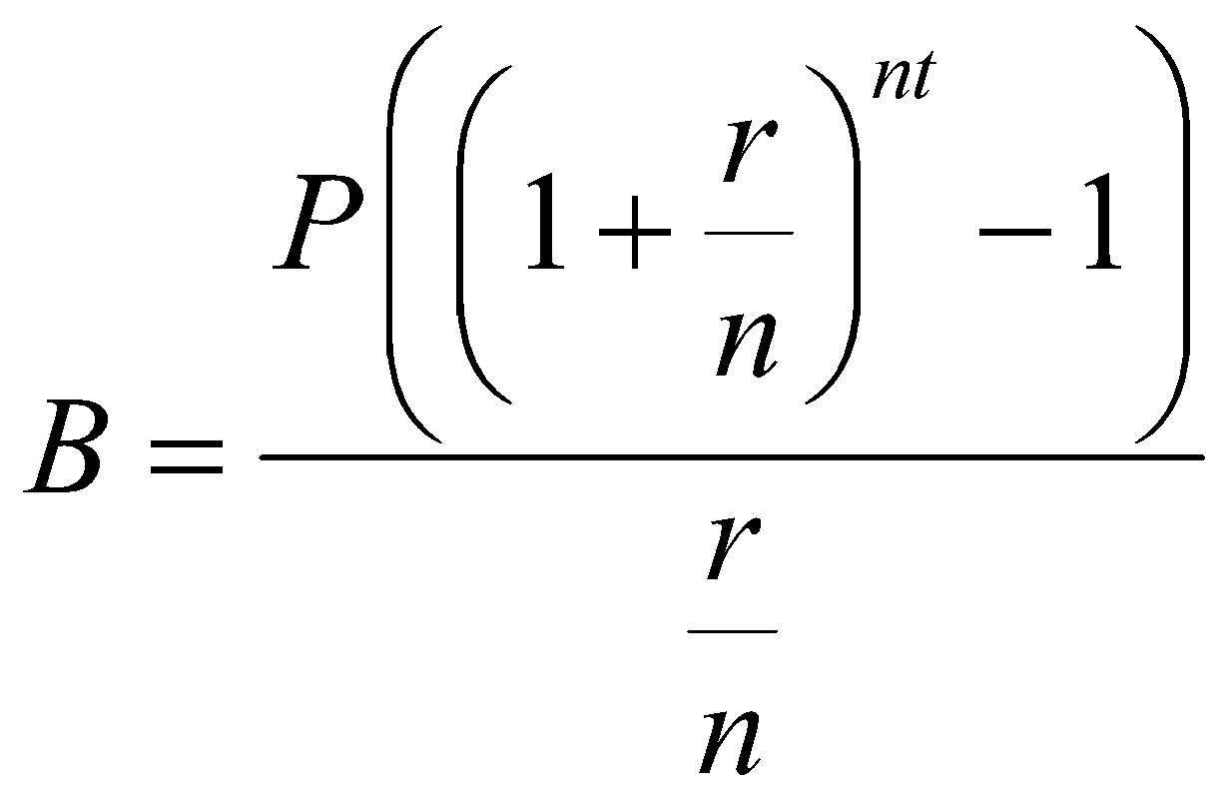
B = balance at end of investment period
P = periodic deposit amount
r = annual interest rate expressed as decimal
n = number of times interest is compounded annually
t = length of investment in years

Example 1:
Rich and Laura are both 45 years old. They open an account at the Mission Savings Bank with the hope that it will gain enough interest by their retirement at the age of 65. They deposit $5,000 each year into an account that pays 4.5% interest, compounded annually.

- What is the account balance when Rich and Laura retire?

- How much more would Rich and Laura have in their account if they decide to hold off retirement for an extra year?

- How much interest will Rich and Laura earn over the 20-year period?

Example 2:
Linda and Rob open an online savings account that has a 3.6% annual interest rate, compounded monthly. If they deposit $1,200 every month, how much will be in the account after 10 years?

3.8 Present Value of Investments
Key Terms:
Present Value | _____________ value of a deposit that is made in the _______________ time.
Present Value of a Single Deposit Investment | How much a ________ ________ deposit should earn at a specific interest rate in order to have a certain amount of money saved for a future savings goal.
Present Value of a Periodic Deposit Investment | How much to save on a ___________ _________ at a specific interest rate to meet that ____________ goal.
***Present Value Periodic and Present Value Single deposits determine what you need to save ______.

Present Value of a Single Deposit Investment Formula

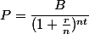
B = ending balance
P = principal or original balance (present value)
r = annual interest rate expressed as decimal
n = number of times interest is compounded annually
t = number of years

Example 3:
Mr. and Mrs. Johnson know that in 6 years, their daughter Ann will attend State College. She will need about $20,000 for the first year’s tuition. How much should the Johnsons deposit into an account that yields 5% interest, compounded annually, in order to have that amount? Round your answer to the nearest thousand dollars.

Example 4:
Ritika just graduated from college. She wants $100,000 in her savings account after 10 years. How much must she deposit in that account now at a 3.8% interest rate, compounded daily, in order to meet that goal? Round up to the nearest dollar.

Present Value of a Periodic Deposit Investment Formula

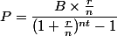
B = ending balance
P = principal or original balance
r = annual interest rate expressed as decimal
n = number of times interest is compounded annually
t = number of years

Example 5:
Nick wants to install central air conditioning in his home in 3 years. He estimates the total cost to be $15,000. How much must he deposit monthly into an account that pays 4% interest, compounded monthly, in order to have enough money? Round up to the nearest hundred dollars.

