Checking Accounts & Bank Statements
Key Terms:
Checking Account
Electronic Funds Transfer
Check Clearing
Insufficient Funds
Maintenance Fee
Bank Statement
Outstanding Transactions
Reconciling

Banks vs. Credit Unions

Types of Checking Accounts

Importance of Reconciling Accounts

Example 1: Nick has a checking account with the Park Slope Savings Bank. He writes both paper and electronic checks. For each transaction, Nick enters the necessary information: check number, date, type of transaction, and amount. Determine the balance in his account.
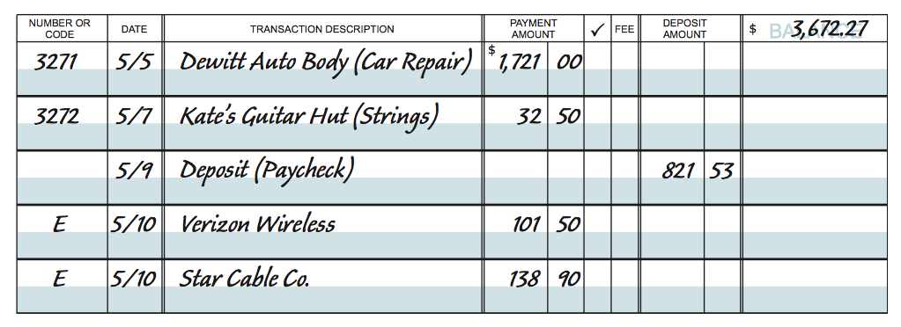
Example 2: Jacob has an account at Timberwolf National Bank. His balance at the beginning of January was $5,195.65. During the month, he made deposits of $6,873.22, wrote checks totaling $4,871.90, paid a maintenance fee of $12, and earned $11.15 in interest on the account. What was the balance at the end of the month?

Example 3: (page 121, #13)
Create a check register for the transactions listed. There is a $2.25 fee for each ATM use.

a. Your balance on 10/29 is $237.47

b. You write check # 115 on 10/29 for $18.00 to El Camino High School.

c. You deposit a paycheck for $162.75 on 10/30.

d. You deposit a $25 check for your birthday on 11/4.

e. On 11/5, you go to a sporting event and run out of money. You use the ATM in the lobby to get $20 for snacks.

f. Your credit card bill is due on 11/10, so on 11/7 you write a check to Credit USA for $51.16.

g. Your sister repays you $20 on 11/10. You deposit it.

h. You withdraw $25 from the ATM to buy flowers on 11/12.

i. You deposit your paycheck for $165.65 on 11/16.

j. You deposit a late birthday check for $35 on 11/17.

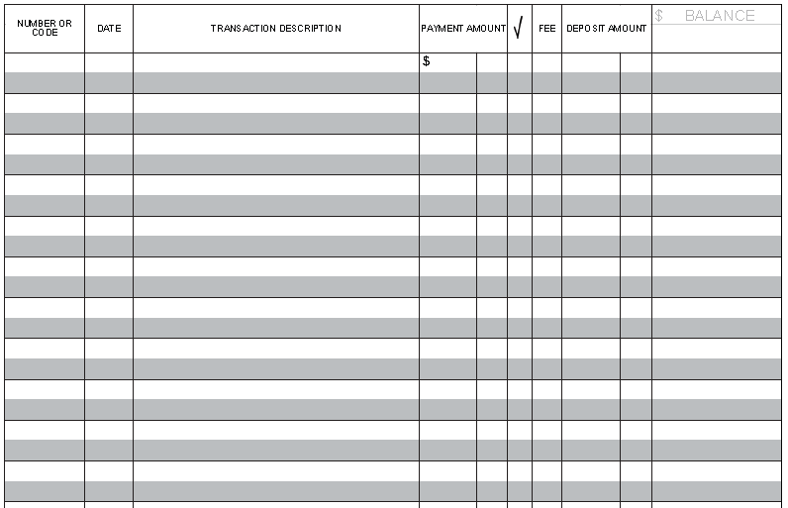

Example 4:
Use Tina Weaver’s monthly statement and check register to reconcile her account.
- What is the ending balance on the statement?
- What is the total of the outstanding deposits?
- What is the total of the outstanding withdrawals?
- What is the revised statement balance?
- What is the balance of the check register?
- Does the account reconcile?
