Financial Algebra Chap 2 Day 2 Name: ________________________ Per: ____
Practice 1: Complete all the necessary information in the check register.
- The balance on January 1 is $3,900.50.
- On January 2, check #1223 is written for $84 to Mission Vista High.
- On January 3, a paycheck in the amount of $240.80 is deposited.
- On January 4, a birthday check for $100 is received from grandparents. The check is deposited that afternoon.
- On January 8, three debit transactions occur. One is to Macy’s in the amount of $480.21, one is to Wal-Mart in the amount of $140.58, and one is to Old Navy in the amount of $215.60.
- Staples sells computers. On January 11, a laptop is purchased for $1,250. A mistake is made on the first check, and the check must be voided. A correct check for the right amount is then written with the next available check.
- On January 13, a textbook is returned to Barnes and Noble. The $120 amount is deposited into the checking account.
- On January 15, $300 is withdrawn from an ATM for a lunch plan at school. The company that owns the ATM charges $1.50 fee for the transaction, and the customer’s bank charges a $2.50 fee for the transaction. The fees are taken directly out of the checking account.
- On January 19, a check for $521 is written to Eyton’s Auto Body Shop to repair a dent in the fender of a car.
- On January 20, a check is written to AMTRAK for $150.80 to visit Cal Poly’s college campus.
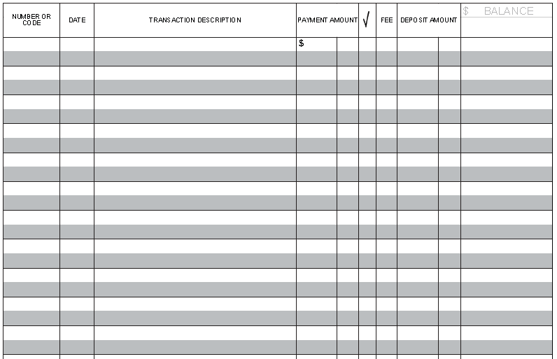

Practice 2:
Fill in the missing balances in Raymond Marshall's check register below.
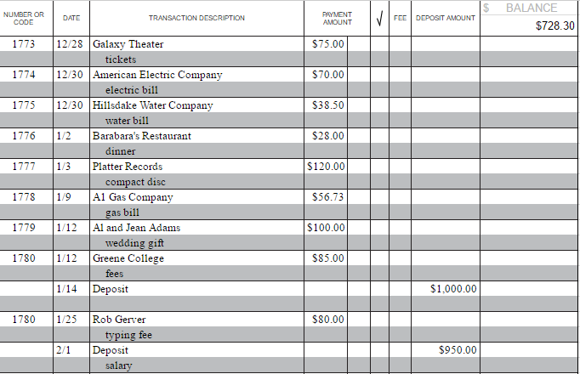
Does Raymond Marshall's check register reconcile with his statement shown below? Explain.

