Day 1-3 Banking Review
Don’t forget to review all Chapter 3 vocabulary up to this point!
1. Complete all the necessary information in the check register.
- The balance on February 8 is $4,582.97.
- On February 12, check #273 is written for $211.23 to Buddy’s Allstars.
- On February 13, a paycheck in the amount of $617.89 is deposited.
- On February 15, a birthday check for $40 is received from your aunt. The check is deposited that day.
- On February 23, two debit transactions occur. One is to Nordstrom in the amount of $1,023.15 and one is to Sprouts in the amount of $57.56.
- Office Depot sells calculators. On February 24, a swanky calculator is purchased for $92.85. A mistake is made on the first check, and the check must be voided. A correct check for the right amount is then written with the next available check.
- On February 25, a blouse is returned to Nordstrom. The $58 amount is deposited into the checking account.
- On February 26, $200 is withdrawn from an ATM for a day at disneyland. The company that owns the ATM charges a $2.75 fee for the transaction, and the customer's bank charges a $1.25 fee for the transaction. The fees are taken directly out of the checking account.
- On February 27, a check for $1,200 is written to Wetmore Dental for a root canal.
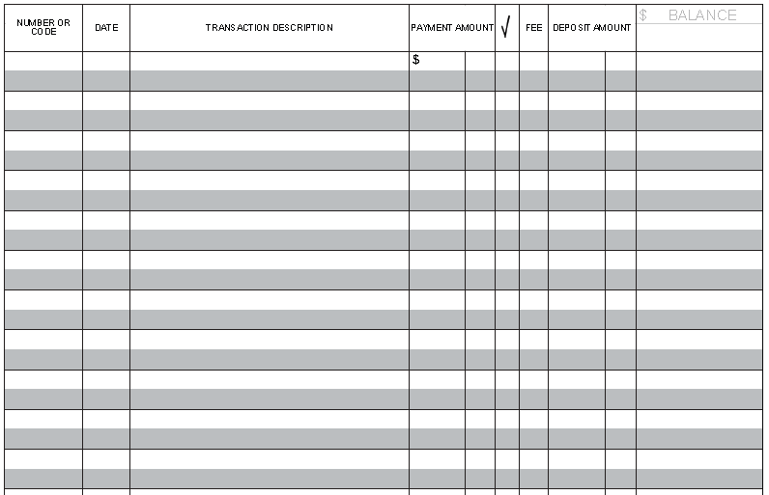

2. Reconcile the checking account.

