Compound Interest
Key Terms:
Crediting | The bank ____________________ interest every single day, based on that day’s __________________ , but does not add the interest every day. Instead, they keep a ______________ of interest earned and ______ it into the account monthly or quarterly.  ________ common procedure in banks today is compounding daily and crediting ______________.
Annual Percentage Rate
Annual Percentage Yield | The ______ is the ___________ interest rate it would take to give the same dollar amount of interest that the compounding gave.
Compound Interest | With ________________ interest, the account earns interest on the _________________, so the principal __________ any earned interest is used to calculate the interest.  Each time interest is calculated the principal is slightly ____________ than the previous time because of the __________ interest
Interest can be compounded for different ________ periods.
Compounding | # times per year | This is every ____
Annual
Semiannual
Quarterly
Monthly
Daily
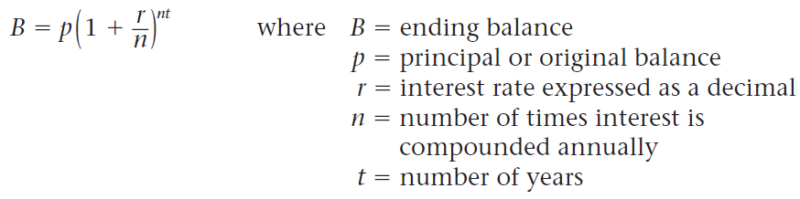
Compound Interest Formula:
Example 1:
Marie deposits $1,650 for three years at 3% interest, compounded daily. What is her ending balance?

Example 2:
Kate deposits $2,350 in an account that earns interest at a rate of 3.1%, compounded monthly. What is her ending balance after five years? Round to the nearest cent.

Example 3:
Write an algebraic expression for the ending balance after k years of an account that starts with a balance of $2,000 and earns interest at a rate of 3.5%, compounded daily.

Annual Percentage Yield Formula
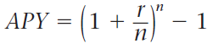 NOTE: the starting amount does NOT matter!
Most banks advertise the APY. It is important to find out the APR as well as the APY on an account before you ____________ it.

Example 4:
Barbara deposits $3,000 in a one year CD at 4.1% interest, compounded daily. What is the annual percentage yield (APY) to the nearest hundredth of a percent?

Example 5:
Spencer deposits $10,000 in a two year CD at 1.9% interest,compounded monthly. What is Spencer’s APY to the nearest hundredth of a percent?

