**Continuous Compounding**

*Key Terms:*

|  |  |
| --- | --- |
| Continuous Compounding |  |
| Exponential base (e) |  |

To develop an equation to determine continuously compounded interest,

let P= **1**, r = 100% = **1**, and t = **1**. Let n 🡪 **∞** .

|  |  |  |  |
| --- | --- | --- | --- |
| n | |  |  |
| Yearly | n = 1 |  | 2 |
| Quarterly | n = 4 |  |  |
| Monthly | n = |  |  |
| Daily | n = |  |  |
| Hourly | n = |  |  |

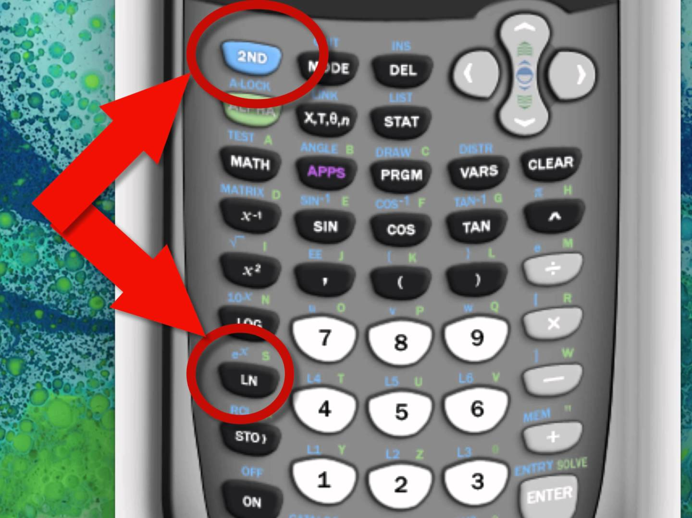**Continuous Compound Interest Formula:**

**Example 1:** If you deposit $1,000 at 4.3% interest, **compounded continuously**, what would your ending balance be to the nearest cent after five years?

**Example 2:** Craig deposits $5,000 at 5.12% interest, **compounded continuously** for four years. What would his ending balance be to the nearest cent?

**Example 3:** Patti wants to deposit $1,000 and keep that money in the bank without deposits or withdrawals for eight years. She compares two different options. Option 1 will pay 2.7% interest, compounded quarterly. Option 2 will pay 2.4% interest, compounded continuously.

**a.** How much interest does Option 1 pay?

**b.** How much interest does Option 2 pay?