Financial Algebra
Chap 7 Day 4 Floor Plans
Be able to read a floor plan; compute the area and perimeter.

Word | Definition
Floor Plan

Needs | Wants
Minimum Square Footage: 400 Maximum Square Footage: 2,000

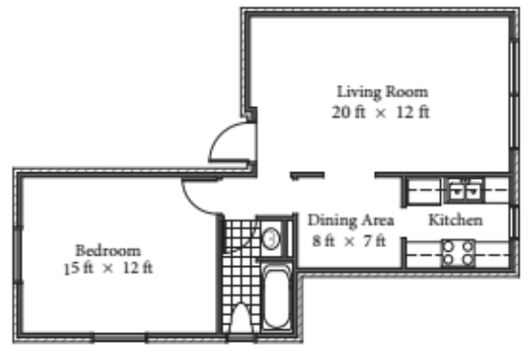

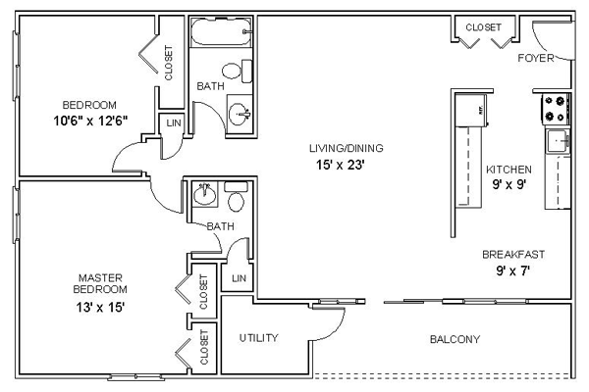

Example 1: Jerry is using the floor plans for his new home to help him purchase base molding for the place where the walls meet the floor. The plans are drawn using a scale of ¼ inch represents 1 foot. He measures the walls on the floor plan with a ruler and finds that they total 23½ inches. If molding costs $2.10 per foot, how much will Jerry spend on molding?

Example 2: Gabriela plans to carpet her living room, except for the quarter-circle shown in the corner. That area will be a wood floor where she will put her piano. The radius of the quarter circle is 8 feet. If carpeting costs $9.55 per square foot, what is the cost of the carpeting she will use in her living room?

