Budgeting
Understand the major components of an independent adult’s budget.
Become familiar with vocabulary needed to budget appropriately.
Word | Definition
Budget
Discretionary Spending
Expenditures
Surplus
Deficit
Impulse Buying
Long-Term Goals
Short-Term Goals

Needs | Wants

Assess your values around purchases
Review the list below, putting a:
- 1 next to those that are needs for you,
- a 2 next to high priority wants, and
- a 3 next to low priority wants.
- You can leave some blank if they don’t fit into your lifestyle at all.
# | ITEM |  | # | ITEM
 | In-style clothing or the latest trends |  |  | Personal hobbies (membership or entry fees, equipment, uniforms, etc)
 | Subscriptions (Netflix, Hulu, magazines, newspapers, etc) |  |  | Professional expenses (books, resources, subscriptions, membership fees, conference attendance, etc)
 | At-home entertainment (books, movie rental, music purchases, hosting friends, etc) |  |  | Out-of-home entertainment (amusement parks, movies, bowling, etc)
 | Cable television |  |  | Charitable donations
 | Vacations, travel |  |  | Vehicle upgrades
 | Electronics (tv, stereo, video games, phones, etc) |  |  | Non-essential beauty/hygiene or grooming items/services
 | Holiday and other gift giving |  |  | Premium or pay-per-view cable content
 | Eating out |  |  | Gym membership
 | Premium coffee (Starbucks, etc)
Average Family Budget  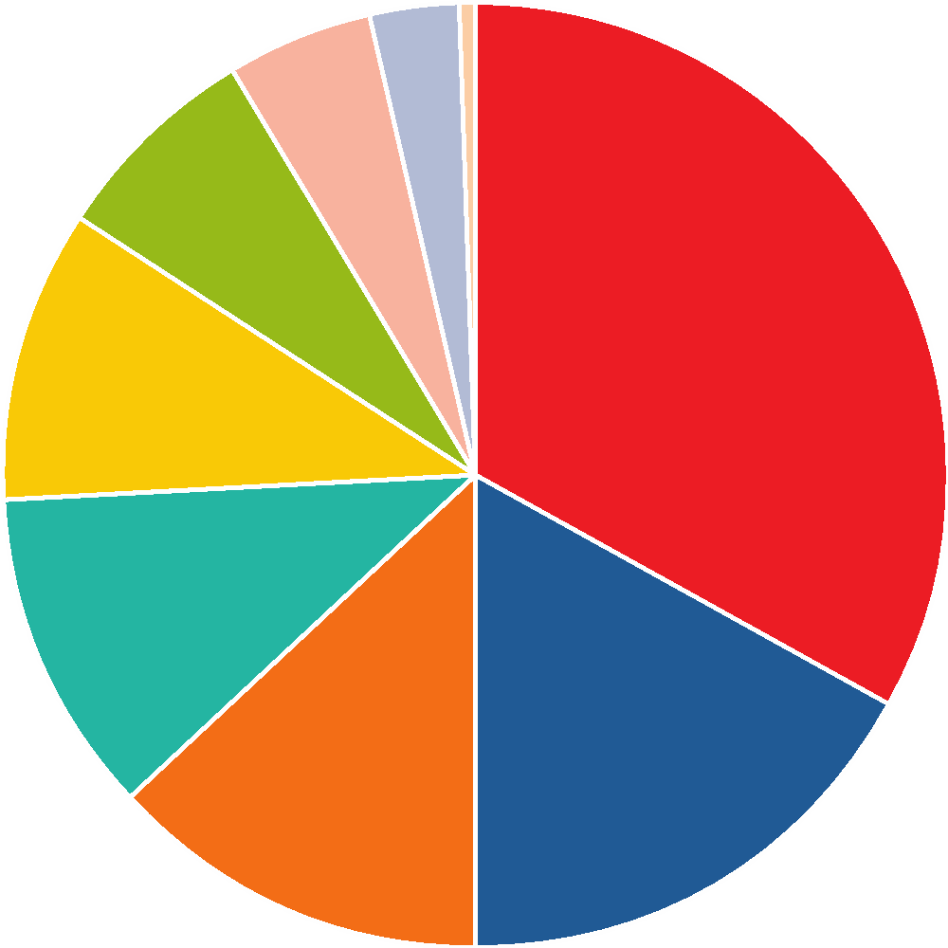 | Creating a Budget  1.  2.  3.  4.
Tricks for Building a Budget  1.  2.  3.  4.  5. | 6.  7.  8.  9.  10.
50-20-30 Plan
50%
20%
30%
Actual Numbers (Household of 3 (2 adults, 1 child); 2 dogs and a cat)
Automobile  Gas $_______  Service and Parts $_______  Food  Groceries $_______ | Eating Out (fast food and restaurants) $_______  Kids $_______  (supplies- like diapers and wipes, clothing, activities, toys)  Pets (food, vet., grooming, medicine) $_______

