Review of Credit
Word | Definition
Credit
Advantages and Disadvantages of Credit
Advantages | Disadvantages
Why do banks issue credit?
Banks issue credit to consumers to 1) make money and 2) offer service to customer.
What are the 3 C’s?
Character | Capital | Capacity
Will you repay the debt? | What if you don’t repay the debt? | Can you repay the debt?
Your Responsibilities
- ____________ only what you can __________.
- Read and ______________________ the credit ________________.
- ___________________________________.
- ____________ creditor if you ____________ meet payments.
- Report ________ or ____________ credit cards promptly.
- Never give your ______________________ over the phone unless you initiated the call or are certain of the caller’s identity.
How to Build a Credit History

Types and Sources of Credit
Single-Payment Credit
Items and services are _________ for in a ____________ payment, within a given time period, after the purchase. _________________ is usually ______ charged.
Examples:
Revolving Credit
________ items can be ____________ using this plan as long as the __________ amount does not go over the credit user’s assigned dollar limit. Repayment is made at ______________ time intervals for any amount at or __________ the _______________ required amount. Interest is ____________ on the remaining ________________.
Examples:
Installment Credit
Merchandise, services, or money loaned, which are paid back in two or more regularly scheduled payments. Interest is included.
Examples:

20-10 Rule

Example 1: You earn $400 a month after taxes. What is the maximum amount of debt you should have?
What amount should your monthly debt payment not exceed?

Example 2: Jen and Jacob have a combined monthly net income of $5,700. Their fixed monthly expenses consist of $1,675 for rent. They also have an outstanding student loan balance of $6,000 and a balance of $2,000 for some home renovation materials they bought last month. How much more debt can they take on and still be within a safe debt load?

Example 3: Vicki has a monthly net income of $3,450. Her fixed monthly expenses consist of $900 for rent. She also pays a car insurance premium of $108 and a car payment of $367. Are these payments within Vicki’s safe debt load?

Parts of a Credit Card
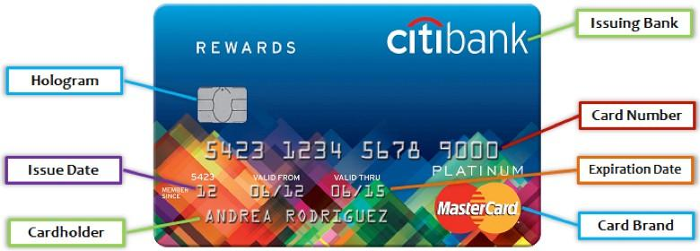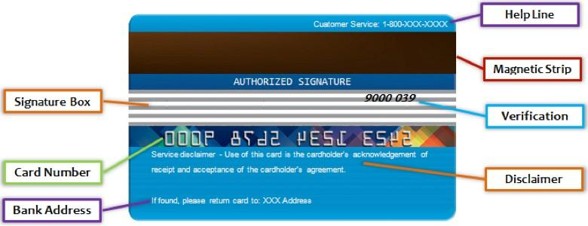

Interesting Fact -

