3.5 Notes
Credit Card Statements
Identify and use the various entries in a credit card statement.

Word | Definition
Credit Line
Payment Due Date
Transactions

What information does a credit card statement give you?

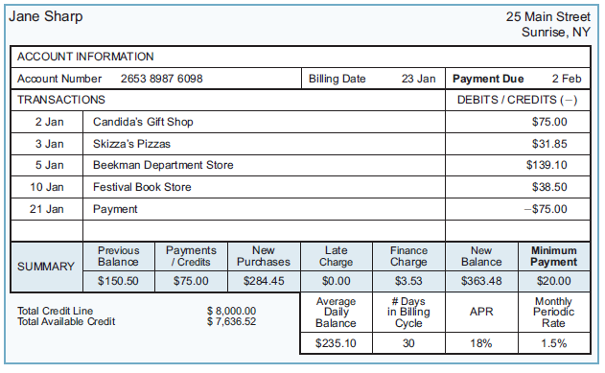
Example 1:
- What is the date of the statement?
- What is the APR?
- What is the monthly periodic rate?
- What is the new balance?
- What is the previous balance?
- How many charges were made during the billing cycle?
- How many credits/payments were made during the billing cycle?
- Were there any charges for late payments?
- What is the total amount of credit line?
- Did Jane pay bill in full last month? How do you know?

SAMPLE STATEMENT
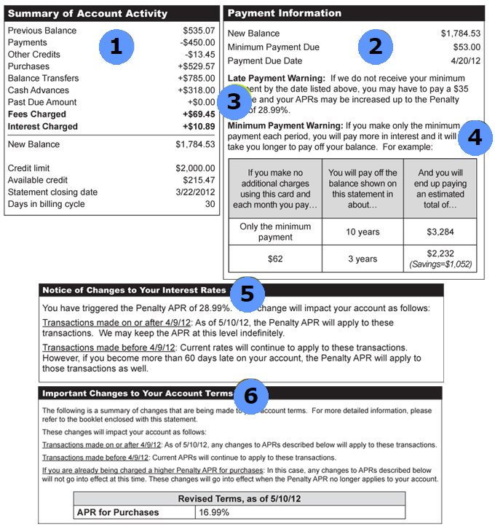
©2012, Federal Reserve Bank of St. Louis Permission is granted to reprint or photocopy this lesson in its entirety for educational purposes, provided the user credits the Federal Reserve Bank of St. Louis, www.stlouisfed.org/education

1. 2. 3. 4.

5. 6.
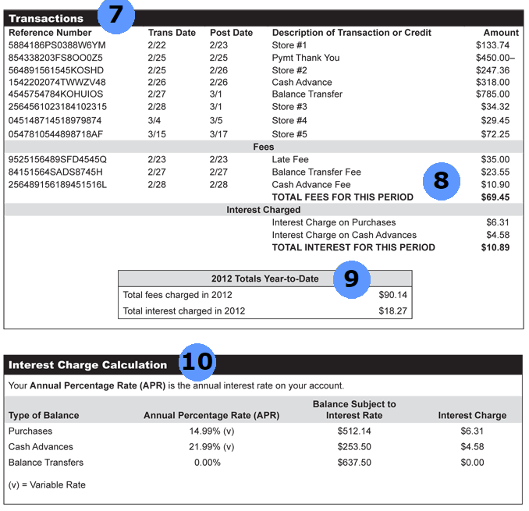
©2012, Federal Reserve Bank of St. Louis Permission is granted to reprint or photocopy this lesson in its entirety for educational purposes, provided the user credits the Federal Reserve Bank of St. Louis, www.stlouisfed.org/education

7. 8. 9. 10.

Example 2:
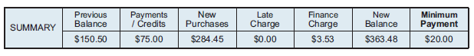
The summary portion of a credit card statement is shown above.
- Explain how the new purchases amount was determined.
- Explain how the new balance amount was determined.

Example 3: Suppose you create the following spreadsheet that models the statement summary and input the values in row 2. Write the spreadsheet formula to compute the new balance for cell F2.
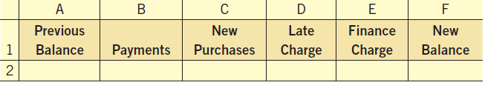

Example 4: Nicole has a credit line of $10,000 on her credit card. Her summary looks as follows. How much available credit does Nicole have?
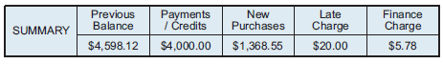
Find the new balance.

Find her available credit.

Example 5: Mr. Tyson is examining the summary section of his credit card statement. Mr. Tyson has checked all the entries on his bill and agrees with everything except the new balance. Determine where the error was made.
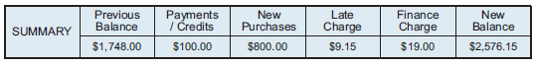

Example 6: The APR on Josh’s credit card is currently 20.4%. What is the monthly periodic rate?

Example 7: Megan’s monthly periodic rate is 1.35%. What is the APR?

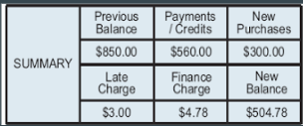
Example 8: Determine the error that was made using the following summary statement.

