3.6 Notes
Average Daily Balance
Calculate the average daily balance and finance charge using the credit calendar.
Word | Definition
Average Daily Balance
Credit Calendar
Billing Date
How are the entries on the monthly statement calculated?
Credit card users who do not pay their bills in full are charged a ______________ ___________ for the extra time. It is computed on the ______________ __________ ______________ if you have an unpaid balance on your card. Each card is different in its ______________ __________ and ______________ ___________.
How do you calculate the average daily balance using a credit card calendar?
Step 1: | Step 2:
Step 3: In one color: Look at the posted dates of each of the charges (debits). Put a plus (+) sign and the charged amount on the calendar dates that have debits posted. Next, look at the posted dates of the payments made. Put a minus sign (-) and the payment made on that calendar date.
Step 4: | Step 5:
Step 6: | Step 7:
Example 1:
Use the information given in Elena Kaye’s credit card statement to verify the accuracy of her average daily balance.
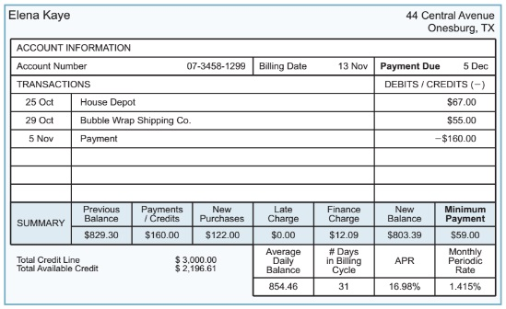
- The average daily balance is ___________________.
- Is there a better time during the billing cycle when Elena could have made her payment so that the average daily balance would have been less?

- Determine the finance charge for Elena's billing cycle.
Finance charge = average daily balance x monthly periodic rate (MPR) [as decimal]

- When might Elena have made her purchases during the billing cycle in order to decrease her finance charge?

Example 2: Use Mark Gilley’s Flashcard Statement to credit a credit calendar. There is an error in his bill. The average daily balance, finance charge, available credit, and new balance amounts are not filled in.

- What is Mark’s average daily balance?

- What is Mark’s finance charge?

- What is Mark’s new balance?

- What is Mark’s available credit?

- If the $200 payment had been posted on 6/13, would Mark’s finance charge for this billing cycle have been higher or lower?

