NGPF Activity Bank

Career #1

ANALYZE: Analyzing a Sample Resume and Cover Letter
Before writing your own resume and cover letter, it’s important to look at some real life examples and discover what elements all great resumes and cover letters have.

- Resume Analysis
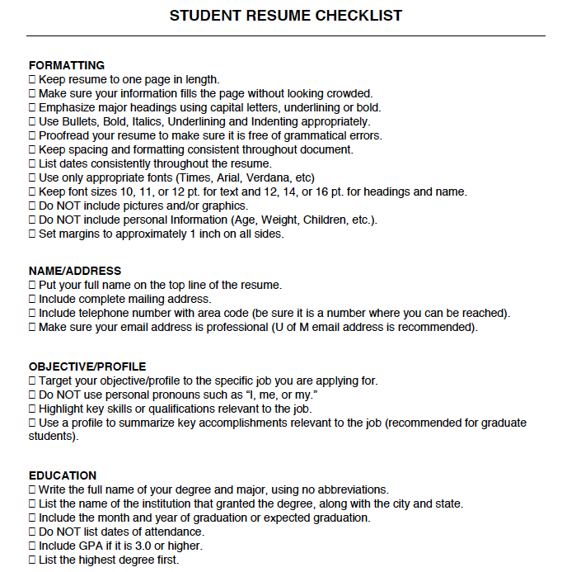

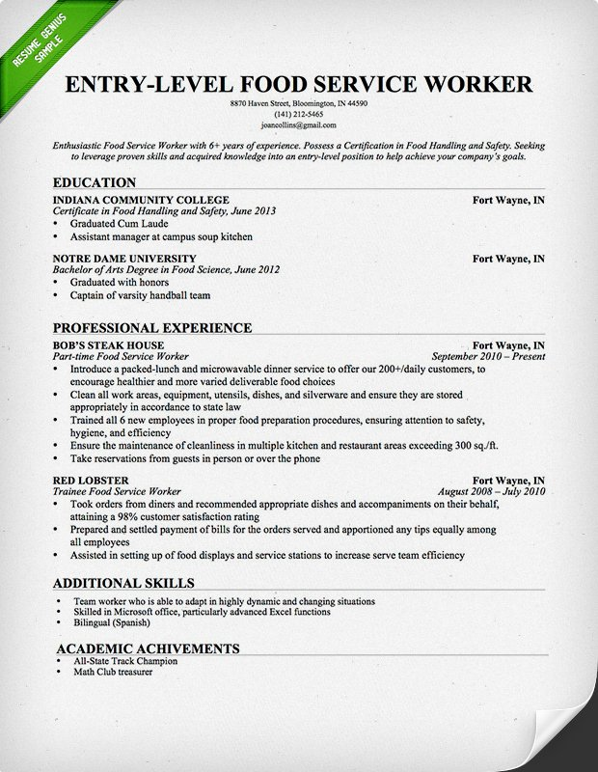

- Cover Letter Analysis

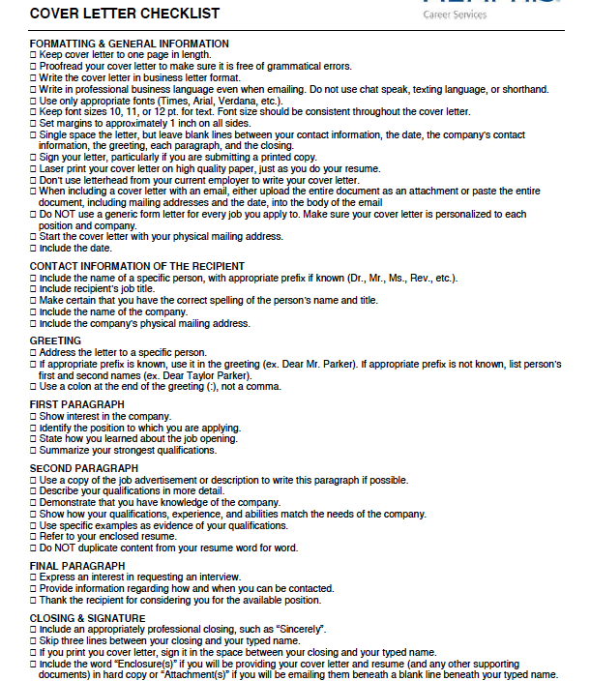
(Sample Cover Letter Original Link)
**NOTE: This cover letter was posted by the employer. His/her contact information, and the contact information of Matthew Ross are both removed from the letter. However, Matthew Ross did include them in the cover letter so note that in your Glows & Grows.

