Chapter 8 Review
Be sure to review ALL key terms from Chapter 8.

- What is the difference between a fixed rate mortgage and an adjustable rate mortgage?

- What does it mean to be evicted from an apartment? What does it mean when a bank forecloses on a house?

- The Smiths took out a $130,000, 30-year mortgage at an APR of 6.5%. The monthly payment was $821.69. What will be their total interest charges after 30 years?

- Allison has a mortgage with North End Bank. The bank requires that she pay her homeowner’s insurance, property taxes, and mortgage in one monthly payment. Her monthly mortgage payment is $1,390, her semi-annual property tax bill is $3,222, and her quarterly homeowner’s bill is $282. How much does Allison pay North End Bank each month?

- If Tom has monthly expenses that total $2,000 and he makes $5,000 a month, what is his debt-to-income ratio? Will the bank give him a mortgage based on this information?

- The length of a room is 20 feet. If a floor plan has a scale of ¼ inch = 2 feet, then what is the length of the room on the floor plan.

- The Jacob’s family is planning to buy a home. They have some money for a down payment already,. They see a home they like and compute that they would need to borrow $213,000 from a bank over a 30-year period. The APR is 6.75%.
  - What is the monthly payment, to the nearest cent?

  - What is the total of all of the monthly payments over the 30 years?

  - What is the total interest for the 30 years?

- Liz and Nick are buying a $725,000 home. They have been approved for a 5.25% APR, 30-year mortgage. They made a 20% down payment and will be closing on March 11.
  - What is their down payment?

  - What is the amount of their loan?

  - What is the monthly payment?

  - What is the interest on the loan?

- The Ungers have an adjusted gross income of $117,445. They are looking at a new house that would carry a monthly mortgage payment of $1,877. Their annual property taxes would be $6,780, and their semi-annual homeowner’s premium would be $710.
  - Find their front-end ratio to the nearest percent.

  - Assume that their credit rating is good. Based on the front-end ratio, would the bank offer them a loan? Explain.

  - The Ungers have a monthly car loan of $430, and their average monthly credit card bill is $5,100. Mr. Unger is also paying $1,000 per month in child support from a previous marriage. Compute the debt-to-income ratio to the nearest percent.

  - If the bank used both the front-end and debt-to-income ratios to decide on mortgage approval, would the Ungers get their mortgage? Explain.

- Calculate the perimeter and area of the apartment below:
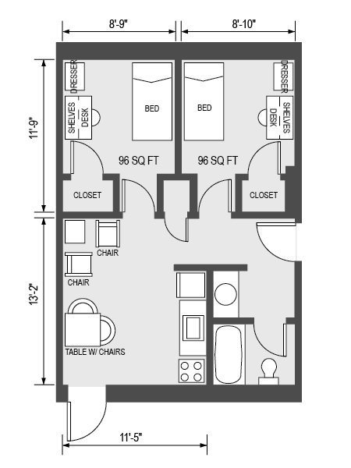

- Name four types of fees you may incur during the closing on the purchase of a new home.

- What three factors influence the price of housing?

- What percentage should debt-to-income be under?

- What percentage should front-end be under?

