Math 3 Name: _________________________
Mod3, Day 3 Date: _______________ Period: ____

Graphing Practice
For each function below, determine the following information. Create a reasonable sketch of the graph on your own graph paper, including intercepts. Indicate the location of any asymptotes (and where they intersect each other).
a) 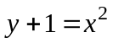 | b) 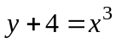
  Parent equation: _____ | Locator point: _____
  Domain: ___________ | Asymptotes: _______
  Range: _____________
  Parent equation: _____ | Locator point: _____
  Domain: ___________ | Asymptotes: _______
  Range: _____________
c) 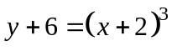 | d) 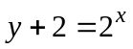
  Parent equation: _____ | Locator point: _____
  Domain: ___________ | Asymptotes: _______
  Range: _____________
  Parent equation: _____ | Locator point: _____
  Domain: ___________ | Asymptotes: _______
  Range: _____________
e) 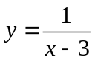 | f) 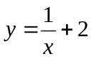
  Parent equation: _____ | Locator point: _____
  Domain: ___________ | Asymptotes: _______
  Range: _____________
  Parent equation: _____ | Locator point: _____
  Domain: ___________ | Asymptotes: _______
  Range: _____________
g) 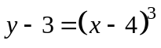 | h) 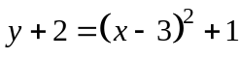
  Parent equation: _____ | Locator point: _____
  Domain: ___________ | Asymptotes: _______
  Range: _____________
  Parent equation: _____ | Locator point: _____
  Domain: ___________ | Asymptotes: _______
  Range: _____________
i) 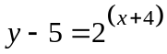 | j) 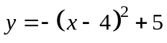
  Parent equation: _____ | Locator point: _____
  Domain: ___________ | Asymptotes: _______
  Range: _____________
  Parent equation: _____ | Locator point: _____
  Domain: ___________ | Asymptotes: _______
  Range: _____________
k) 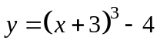 | l) 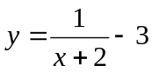
  Parent equation: _____ | Locator point: _____
  Domain: ___________ | Asymptotes: _______
  Range: _____________
  Parent equation: _____ | Locator point: _____
  Domain: ___________ | Asymptotes: _______
  Range: _____________

Naming Functions
Write a possible equation for each of these graphs. Assume that one mark on each axis is one unit.
a) 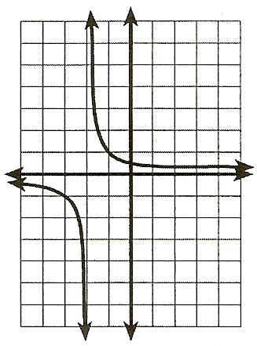  y  x | Orientation: _________  Stretch factor: 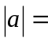____  Horizontal shift: ______  Vertical shift: ________  Locator: ____________  Asymptote(s):________  Equation:  ___________________ | b)  y  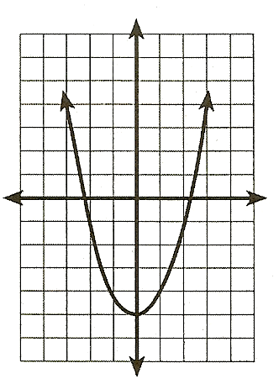  x | Orientation: _________  Stretch factor: ____  Horizontal shift: ______  Vertical shift: ________  Locator: ____________  Asymptote(s):________  Equation:  ___________________
c) 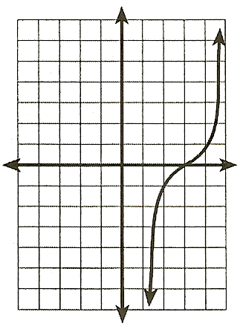  y  x | Orientation: _________  Stretch factor: ____  Horizontal shift: ______  Vertical shift: ________  Locator: ____________  Asymptote(s):________  Equation:  ___________________ | d)  y  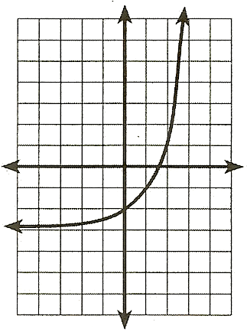  x | Orientation: _________  Stretch factor: ____  Horizontal shift: ______  Vertical shift: ________  Locator: ____________  Asymptote(s):________  Equation:  ___________________
e) 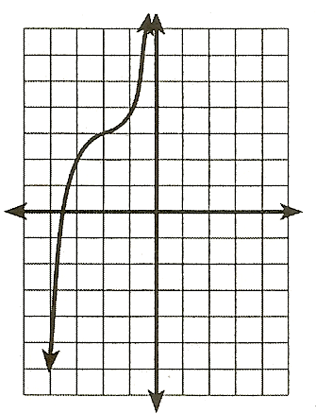  y  x | Orientation: _________  Stretch factor: ____  Horizontal shift: ______  Vertical shift: ________  Locator: ____________  Asymptote(s):________  Equation:  ___________________ | f)  y  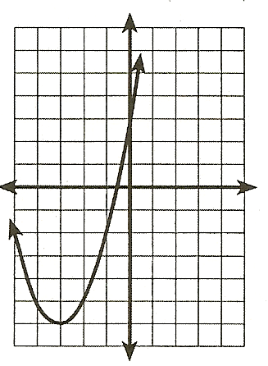  x | Orientation: _________  Stretch factor: ____  Horizontal shift: ______  Vertical shift: ________  Locator: ____________  Asymptote(s):________  Equation:  ___________________
g) 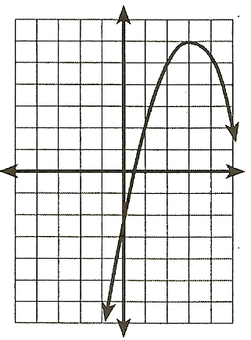  y  x | Orientation: _________  Stretch factor: ____  Horizontal shift: ______  Vertical shift: ________  Locator: ____________  Asymptote(s):________  Equation:  ___________________ | h)  y  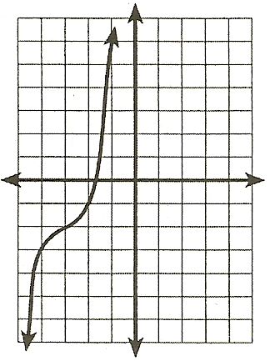  x | Orientation: _________  Stretch factor: ____  Horizontal shift: ______  Vertical shift: ________  Locator: ____________  Asymptote(s):________  Equation:  ___________________

