**Trigonometric Identities**

**Quotient Identities**

displaymath163

**Reciprocal identities**

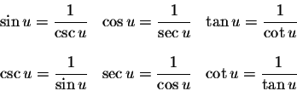

**Sum & Difference Identities**

*sin*(α + β) = *sin*(α)*cos*(β) + *cos*(α)*sin*(β)   
*sin*(α – β) = *sin*(α)*cos*(β) – *cos*(α)*sin*(β)   
*cos*(α + β) = *cos*(α)*cos*(β) – *sin*(α)*sin*(β)   
*cos*(α – β) = *cos*(α)*cos*(β) + *sin*(α)*sin*(β)

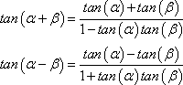

**Even & Odd Identities**

|  |  |
| --- | --- |
| sin (–*x*) = –sin *x*  cos (–*x*) = cos *x*  tan (–*x*) = –tan *x* | csc (–*x*) = –csc *x*  sec (–*x*) = sec *x*  cot (–*x*) = –cot *x* |

**Power-Reducing/Half Angle**

**Formulas**

http://www.mathwords.com/h/h_assets/half%20angle%20identities%20sin%20with%20root.gif  or  http://www.mathwords.com/h/h_assets/half%20angle%20identities%20sin%20squared.gif

http://www.mathwords.com/h/h_assets/half%20angle%20identities%20cos%20with%20root.gif or  http://www.mathwords.com/h/h_assets/half%20angle%20identities%20cos%20squared.gif

http://www.mathwords.com/h/h_assets/half%20angle%20identities%20tan%20with%20root.gif  or  http://www.mathwords.com/h/h_assets/half%20angle%20identities%20tan%20with%20sin%20on%20top.gif  or  http://www.mathwords.com/h/h_assets/half%20angle%20identities%20tan%20with%20sin%20on%20bottom.gif

**Co-Function Identities**

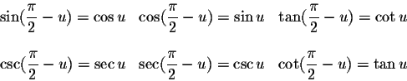

**Pythagorean Identities**

displaymath162

**Double Angle Formulas**

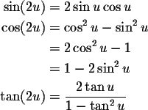

**Sum-to-Product Formulas**

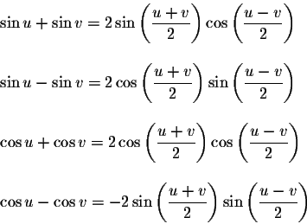

**Product-to-Sum Formulas**

